**Lab 1 – Install Database Firewall**

1. To install a Database Firewall, attach the following file image to the CD drive:

* dbfw‐iinstaller‐disc11‐multi‐5.0-114.iso

To attach the image, click on the Virtual Machine name (e.g. DBFW) and click oon the Settings icon. Click on Storage on the left‐hand menu, and on Empty under IDE Controller. You can then click on t he down arrow next to CDD/DVD Device: Empty. The ISO files you added earlier will be listed. Select disc1 for the required product. Click on OK.

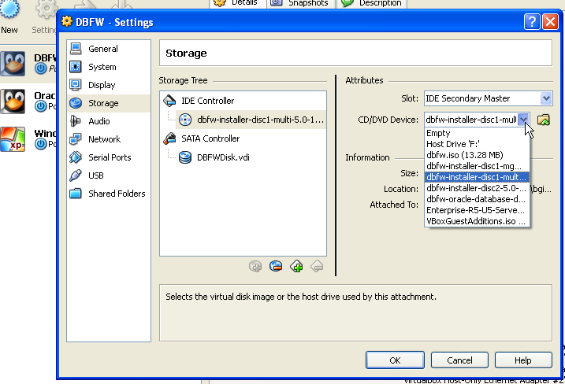

1. With the virtual machine name still selected, click on Start.
2. Click OK at thee Auto capture keyboard message. The virtual machine will now boot onto the attached CD.
3. When prompted for a CD, at the bottom of the screen, right‐click on the image of the CD and select the image requested.
4. Following the Database Firewall installation directions in [Chapter 3 of the Oracle Database Firewall Installation Guide.](http://download.oracle.com/docs/cd/E20465_01/doc/doc.50/e18693/installserver.htm) You are installing Database Firewall and Database Firewall Management Server. You should not need to reorder any network adapters.
5. Set the network settings as follows:
   * **IP Address: 10.200.11.25**
   * **Mask: 255.255.255.0**
   * **Gateway: 10.200.11.1**

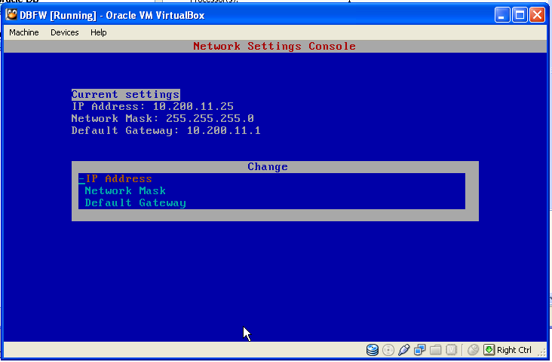

Tip: To return to the main console page on your Firewall box, hit <Alt F1> (It might disappear when you minimize). To use a Linux interface, hit <Alt F2>.

1. Startup the IE browser in your Windows Client image to complete the configuration via the Database Firewall Console. Follow [Chapter 3; Steps 1, 2 and 3 in the Oracle Database Firewall Installation Guide](http://download.oracle.com/docs/cd/E20465_01/doc/doc.50/e18695/standalone.htm#CBBBIHHA). Do not install the Analyzer as this has been completed for you.
2. You can configure the Oracle Database Firewall system settings using the options in the System menu of the System page. You will want to change the keyboard setting from uk to us. After this, you’ll find it easier to work on your Firewall box.
3. Click the Monitoring tab and then click List below the Traffic Sources menu down the left of the user interface. In general, you’ll find the UI organized as “Noun / Verb”.
4. Click ‘Network 0’

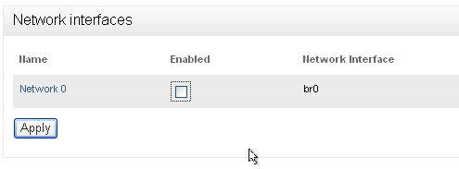

1. Configure the IP address as below, and then click ‘Save Settings’.

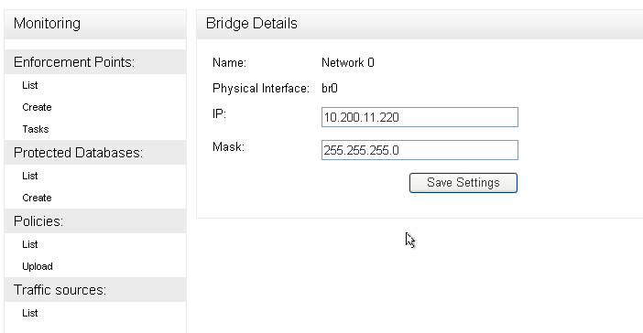

What we found is that if this bridge is not enabled OR IS NOT ON THE SAME SUBNET as your Database Server, you will be able to ping the Database Box but will not be able to tnsping the database.

1. Start SQLPlus on your Windows Client machine and login. ( NOTE: ensure that your database is started on DBSSEC) as system/oracle1.
   * In a command window, type: sqlplus system/oracle1@db01
2. Execute the following command
   * ‐SQL> select * from dual;
3. If all is working, you will get an answer as below:

